

# 

### Semester One Examination, 2019

### Question/Answer booklet

# MATHEMATICS

**APPLICATIONS**

**UNIT 3**

## Section One:

## Calculator-free

**NAME**

**TEACHER**

## Time allowed for this section

Reading time before commencing work: five minutes

Working time: fifty minutes

## Materials required/recommended for this section

***To be provided by the supervisor***

This Question/Answer booklet

Formula sheet

***To be provided by the candidate***

Standard items: pens (blue/black preferred), pencils (including coloured), sharpener,  
correction fluid/tape, eraser, ruler, highlighters

Special items: nil

## Important note to candidates

No other items may be taken into the examination room. It is **your** responsibility to ensure that you do not have any unauthorised material. If you have any unauthorised material with you, hand it to the supervisor **before** reading any further.

## Structure of this paper

|  |  |  |  |  |  |
| --- | --- | --- | --- | --- | --- |
| Section | Number of questions available | Number of questions to be answered | Working  time (minutes) | Marks available | Percentage of examination |
| Section One:  Calculator-free | 8 | 8 | 50 | 52 | 35 |
| Section Two:  Calculator-assumed | 13 | 13 | 100 | 98 | 65 |
|  | | |  | **Total** | 100 |

|  |  |  |
| --- | --- | --- |
| Markers use only | | |
| Question | Maximum | Mark |
| 1 | 6 |  |
| 2 | 5 |  |
| 3 | 7 |  |
| 4 | 6 |  |
| 5 | 8 |  |
| 6 | 6 |  |
| 7 | 7 |  |
| 8 | 7 |  |
| S1 Total | 52 |  |
| S1 Wt (×0.6731) | 35% |  |
| S2 Wt | 65% |  |
| Total | 100% |  |

## Instructions to candidates

1. The rules for the conduct of examinations are detailed in the school handbook. Sitting this examination implies that you agree to abide by these rules.

2. Write your answers in this Question/Answer booklet preferably using a blue/black pen.  
Do not use erasable or gel pens.

3. You must be careful to confine your answer to the specific question asked and to follow any instructions that are specified to a particular question.

4. Show all your working clearly. Your working should be in sufficient detail to allow your answers to be checked readily and for marks to be awarded for reasoning. Incorrect answers given without supporting reasoning cannot be allocated any marks. For any question or part question worth more than two marks, valid working or justification is required to receive full marks. If you repeat any question, ensure that you cancel the answer you do not wish to have marked.

5. It is recommended that you do not use pencil, except in diagrams.

6. Supplementary pages for planning/continuing your answers to questions are provided at the end of this Question/Answer booklet. If you use these pages to continue an answer, indicate at the original answer where the answer is continued, i.e. give the page number.

7. The Formula sheet is not to be handed in with your Question/Answer booklet.

Section One: Calculator-free 35% (52 Marks)

This section has**eight (****8)** questions. Answer **all** questions. Write your answers in the spaces provided.

Working time: 50 minutes.

Question 1 (6 marks)

Consider the following four scatterplots $A$, $B$, $C$ and $D$.

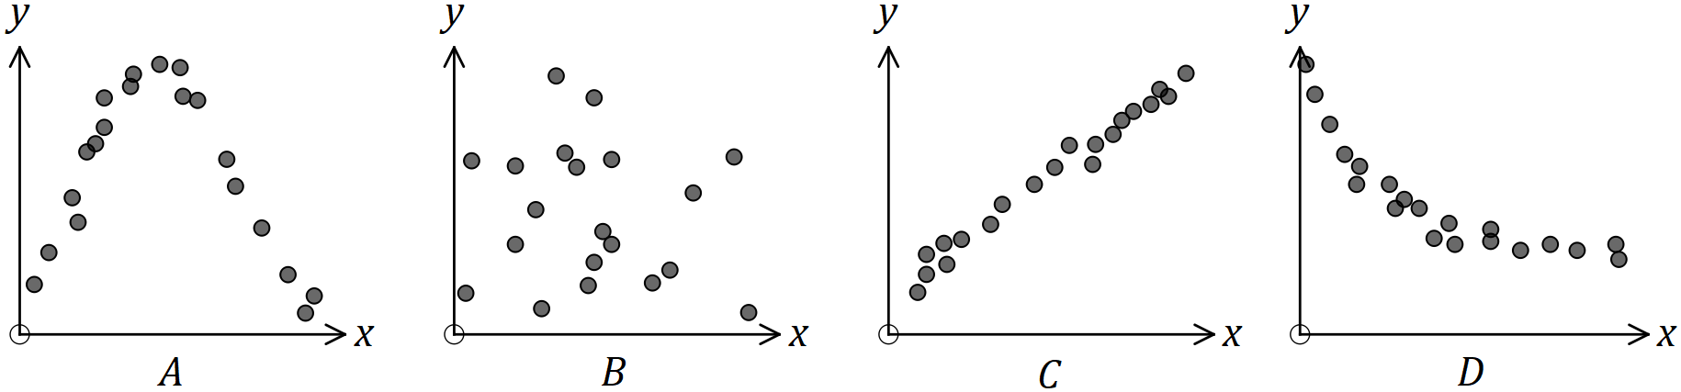

(a) Identify a scatterplot that suggests a non-linear relationship exists between the variables $x$ and $y$. Justify your choice. (2 marks)

(b) Identify a scatterplot that suggests a linear relationship exists between the variables $x$ and $y$. Justify your choice and state the direction of the association. (2 marks)

(c) Identify a scatterplot that suggests no relationship exists between the variables $x$ and $y$. Justify your choice. (2 marks)

Question 2 (5 marks)

Graph $G$ is shown below.

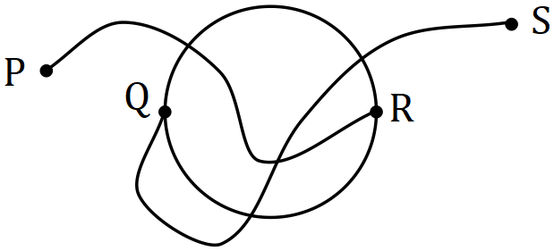

(a) Calculate the sum of the degrees of the vertices of $G$. (1 mark)

(b) State whether the following statements are true or false, briefly explaining your answer in each case.

(i) $G$ is a simple graph. (1 mark)

(ii) $G$ contains a bridge. (1 mark)

(iii) $G$ is a planar graph. (1 mark)

(iv) $G$ satisfies Euler's formula. (1 mark)

Question 3 (7 marks)

(a) If $A_{n+1}=\frac{1}{2}A_{n}, A_{1}=48$ and $B_{n+1}=2B_{n}+3, B_{1}=3.5$ determine $B_{5}-A_{5}$. (3 marks)

(b) Deduce a rule for the th term of the geometric sequence that has $T_{2}=12$ and $T_{3}=4$ and hence or otherwise determine $T_{6}$. (4 marks)

Question 4 (6 marks)

Graph $P$ is shown below.

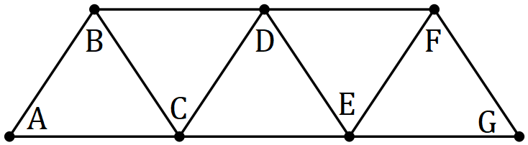

(a) Explain why $P$ is Hamiltonian. (2 marks)

(b) A single edge is to be removed from $P$ so that it is no longer Hamiltonian. Name a suitable edge and state how many other edges you could have chosen. (2 marks)

(c) Draw a connected subgraph of $P$ that has $7$ vertices, $9$ edges and is neither Hamiltonian nor semi-Hamiltonian. (2 marks)

Question 5 (8 marks)

The motor vehicle insurance premium $P$ was recorded to the nearest dollar for eight randomly chosen drivers, together with their age $A$ in years. The data is shown in the table below.

|  |  |  |  |  |  |  |  |  |
| --- | --- | --- | --- | --- | --- | --- | --- | --- |
| Age (Years) $A$ | $$57$$ | $$42$$ | $$35$$ | $$34$$ | $$26$$ | $$53$$ | $$49$$ | $$22$$ |
| Premium ($) $P$ | $$520$$ | $$610$$ | $$610$$ | $$730$$ | $$750$$ | $$470$$ | $$580$$ | $$880$$ |

(a) Construct a scatterplot of this data on the axes below. (3 marks)

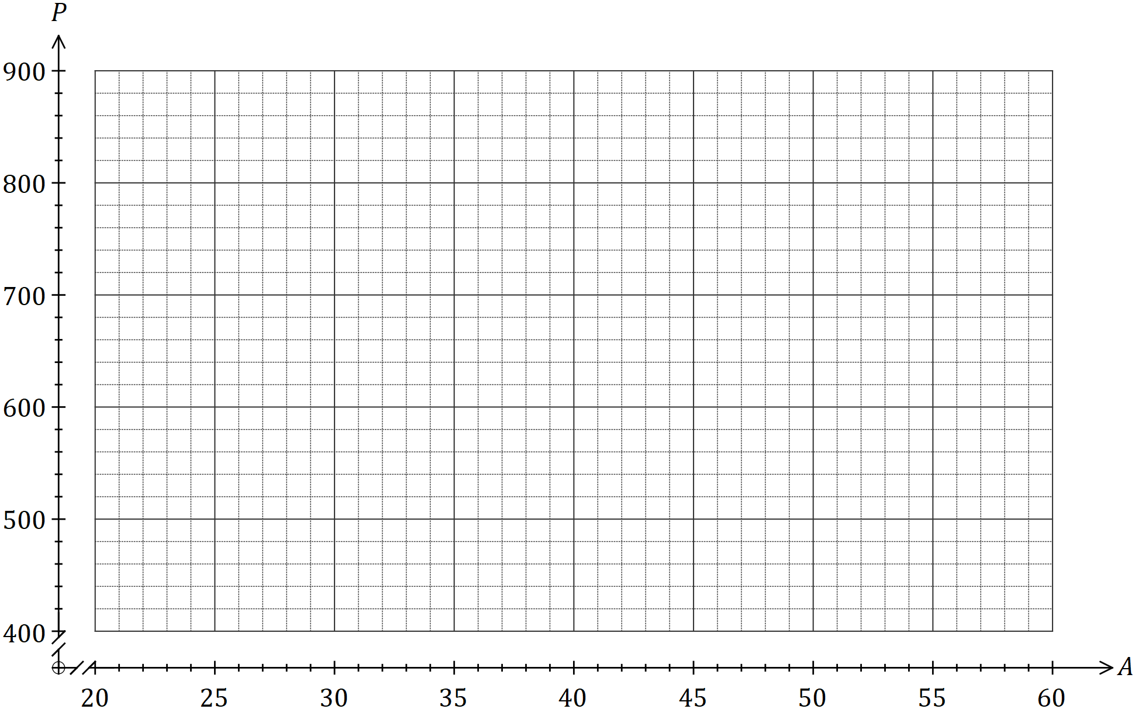

(b) Use features of the scatterplot to fully describe the association that exists between age and premium. (3 marks)

(c) A student looked at the scatterplot and claimed that getting older causes your insurance premium to decrease. Comment on this claim. (2 marks)

Question 6 (6 marks)

(a) Graph $G_{1}$ is shown below.

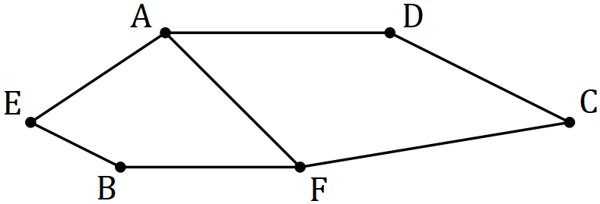

(i) Complete the adjacency matrix for $G_{1}$. (2 marks)

|  |  |  |  |  |  |  |
| --- | --- | --- | --- | --- | --- | --- |
|  | $$A$$ | $$B$$ | $$C$$ | $$D$$ | $$E$$ | $$F$$ |
| $$A$$ |  |  |  |  |  |  |
| $$B$$ |  |  |  |  |  |  |
| $$C$$ |  |  |  |  |  |  |
| $$D$$ |  |  |  |  |  |  |
| $$E$$ |  |  |  |  |  |  |
| $$F$$ |  |  |  |  |  |  |

(ii) Redraw $G_{1}$ to clearly show that it is bipartite. (2 marks)

(b) The adjacency matrix for graph $G_{2}$ is shown below. Show that $G_{2}$ is also bipartite by listing the two distinct groups of vertices. (2 marks)

|  |  |  |  |  |  |  |
| --- | --- | --- | --- | --- | --- | --- |
|  | $$P$$ | $$Q$$ | $$R$$ | $$S$$ | $$T$$ | $$U$$ |
| $$P$$ | $$0$$ | $$1$$ | $$0$$ | $$0$$ | $$0$$ | $$1$$ |
| $$Q$$ | $$1$$ | $$0$$ | $$0$$ | $$1$$ | $$0$$ | $$0$$ |
| $$R$$ | $$0$$ | $$0$$ | $$0$$ | $$1$$ | $$0$$ | $$0$$ |
| $$S$$ | $$0$$ | $$1$$ | $$1$$ | $$0$$ | $$1$$ | $$1$$ |
| $$T$$ | $$0$$ | $$0$$ | $$0$$ | $$1$$ | $$0$$ | $$0$$ |
| $$U$$ | $$1$$ | $$0$$ | $$0$$ | $$1$$ | $$0$$ | $$0$$ |

Question 7 (7 marks)

Some of the terms of a sequence are shown in the graph below.

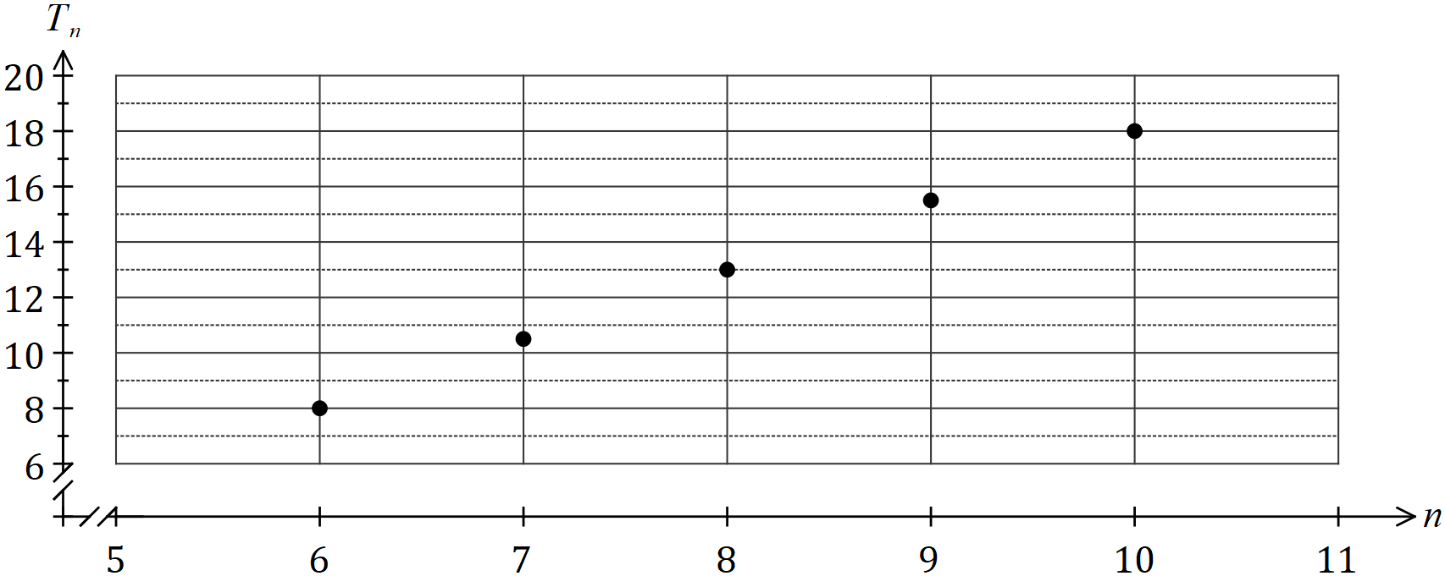

(a) State the name given to this type of sequence and explain the feature of the graph that supports your answer. (2 marks)

(b) Determine

(i) $T_{5}$. (1 mark)

(ii) $T_{1}$. (1 mark)

(c) Determine a rule for the th term of this sequence in the form $T_{n}=an+b$, clearly showing the value of the constant $a$ and the value of the constant $b$. (2 marks)

(d) Determine $n$ given that $T_{n}=493$. (1 mark)

Question 8 (7 marks)

(a) Briefly describe how to draw a graph to show that it is planar. (1 mark)

A connected planar graph $G$ has $2x$ vertices and $3x-3$ edges.

(b) Draw a possible graph for $G$ when $x=3$ that illustrates your answer to (a). (2 marks)

(c) Determine the number of faces of graph $G$ in terms of $x$. (2 marks)

(d) Explain why it is not possible that

(i) $x=1.5$. (1 mark)

(ii) $x=1$. (1 mark)

Supplementary page

Question number: _________

© 2019 WA Exam Papers. Kennedy Baptist College has a non-exclusive licence to copy and communicate this document for non-commercial, educational use within the school. No other copying, communication or use is permitted without the express written permission of WA Exam Papers. SN245-136-1.